CS-23334 FUNDAMENTALS OF DATA SCIENCE
ASHWIN C 240701058

Experiment No: 3 Date: 07.08.2025

3.A Handling Missing Data In a Dataset

Aim:
To demonstrate an experiment to handle missing data and inappropriate data using pandas

Algorithm:
Step 1: Identify Missing Data
Step 2: Quantify and Visualize Missingness
Step 3: Decide on a Strategy (Drop, Impute, Flag)
Step 4: Apply the Chosen Method and Validate

Given Dataset:
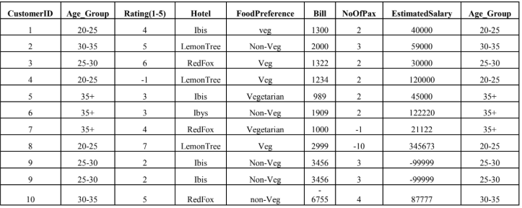

About Dataset:
No.of Columns =9 (called as series – Customer ID, Age Group, Rating(1-5),Hotel, Food Preference, Bill, No Of Pax, Estimated Salary)
CutomerID: Numerical Continuous data
Age: Categorical Data
Rating (1-5): Numerical Discrete Data
Hotel: Categorical Data
Food: Categorical Data
Bill: Numerical Continuous data
NoOfPax: Numerical Discrete
EstimatedSalary: Numerical Continuous data

Code with Output:

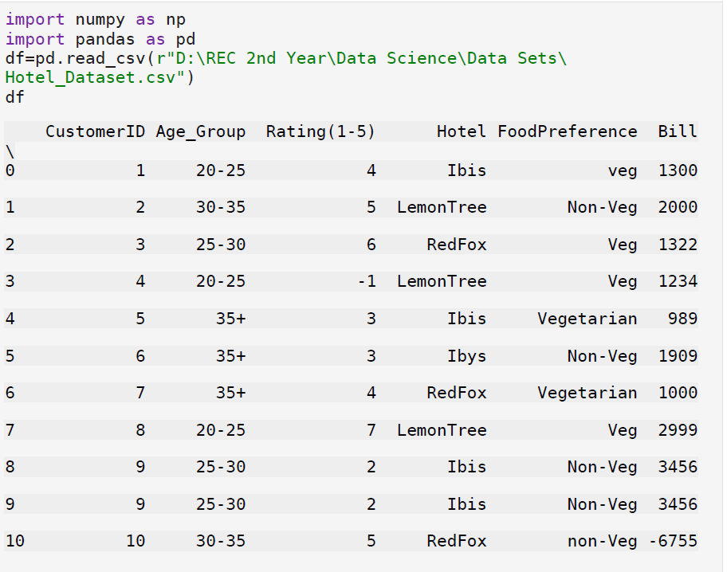

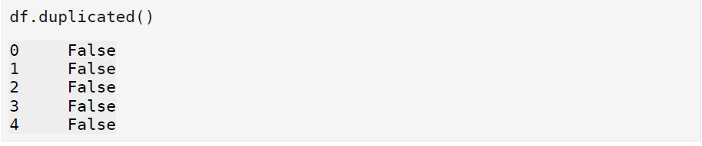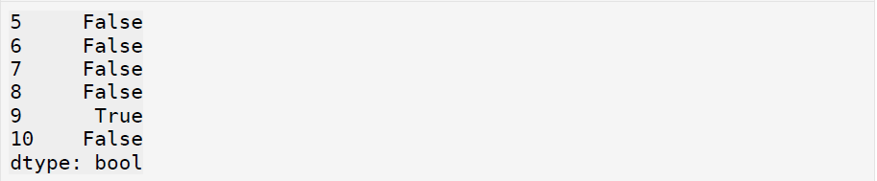

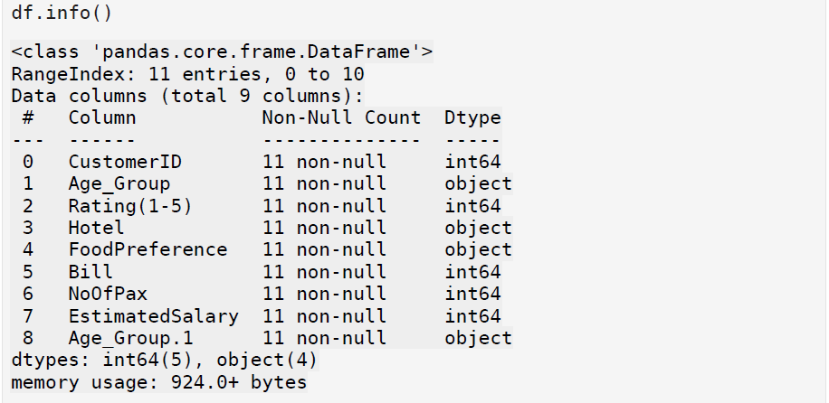

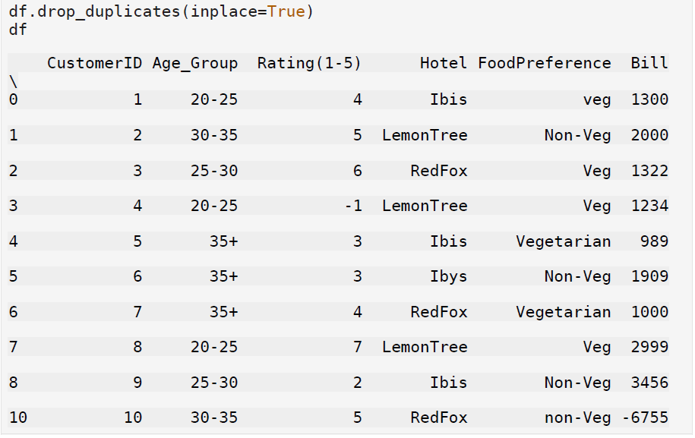
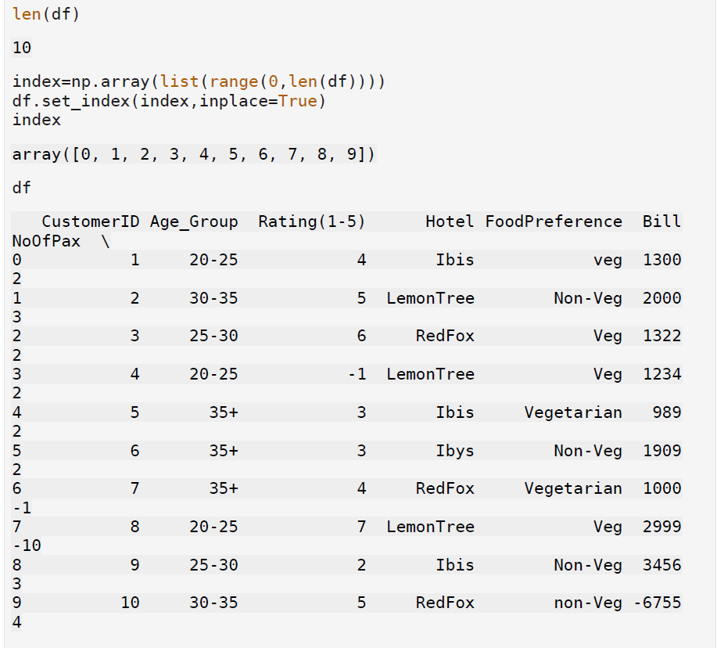

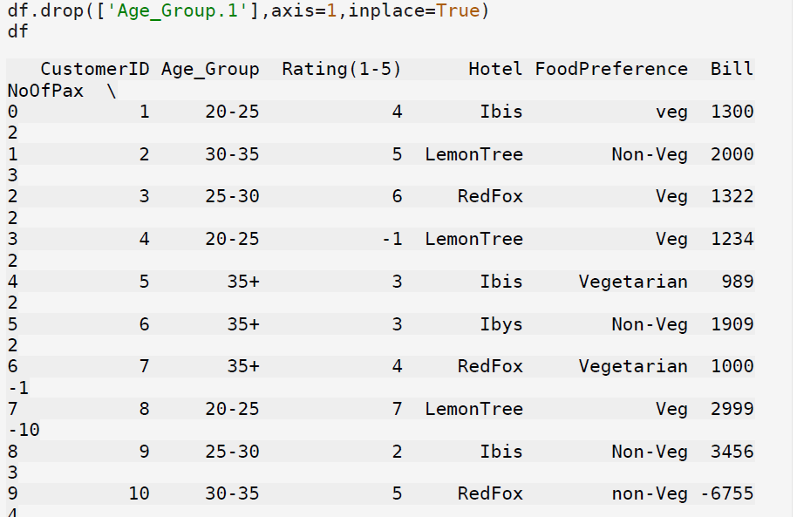

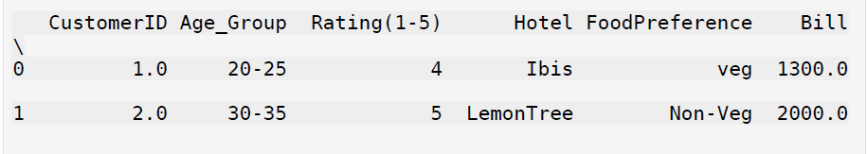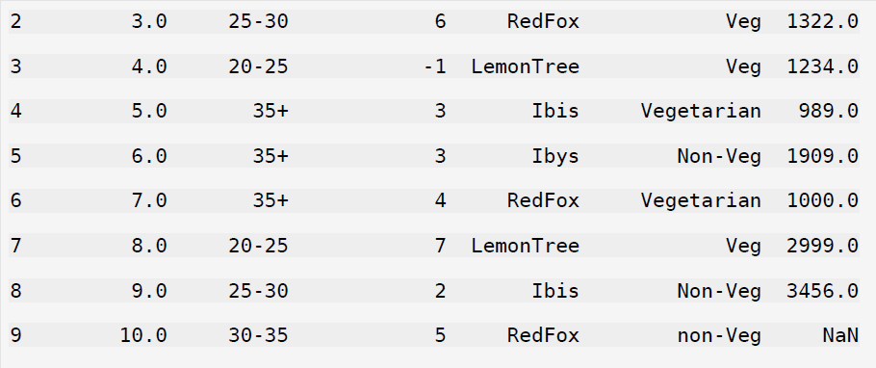

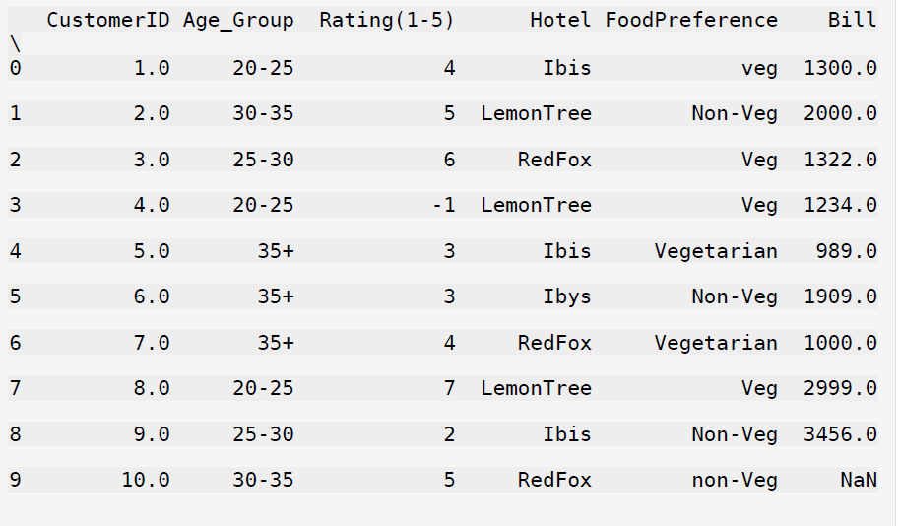

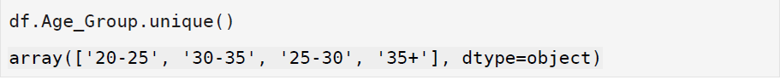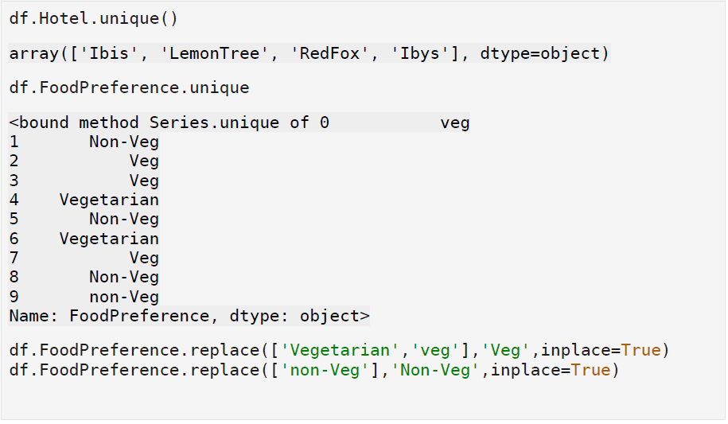

Result:
Thus the process of missing data values handling is carried out using pandas library in Python.

3.B Data Preprocessig In Data Science

Aim:
To understand the data preprocessing in Data Science and understand the importance of data preprocessing in data science.

Algorithm:

Step 1: Data Cleaning
Step 2: Data Transformation
Step 3: Feature Engineering
Step 4: Data Scaling and Encoding

Code With Output:

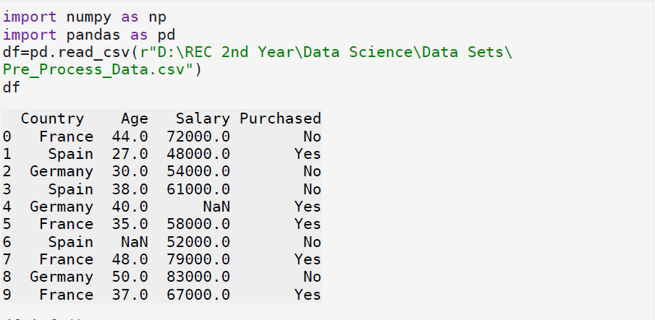

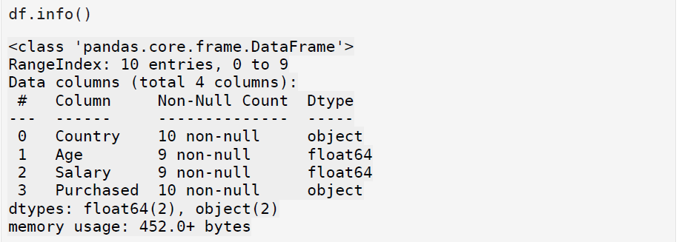

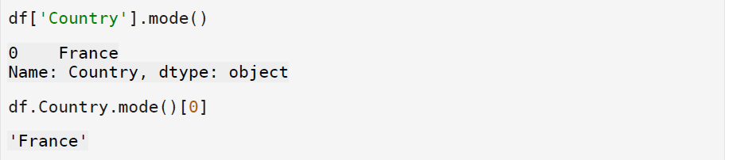

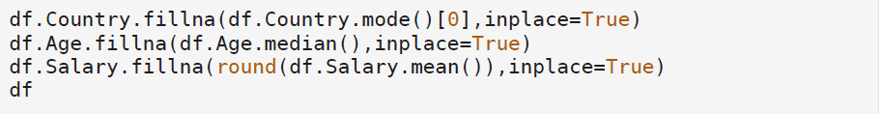

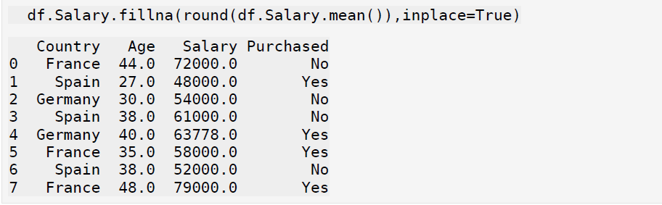

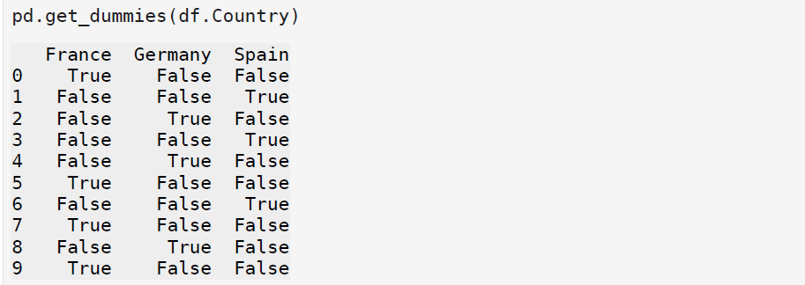

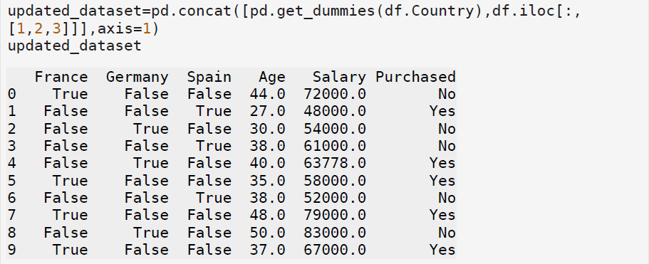

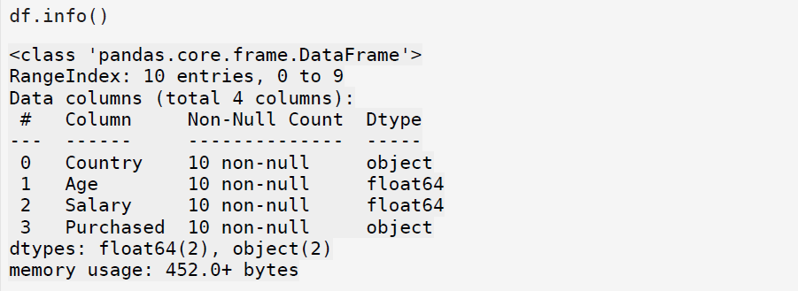
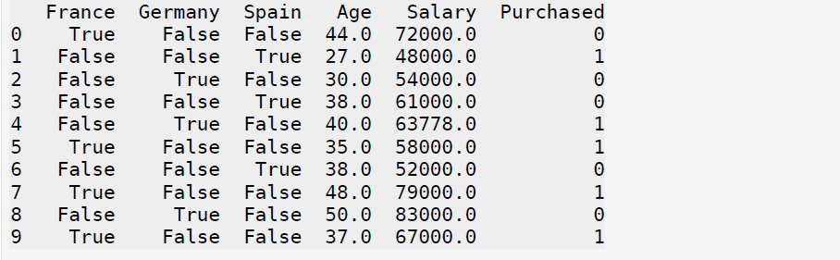

3.C. Create And Save a CSV file Using Pandas

Aim:
To create a CSV File and save the file using Pandas Library in python

Algorithm:

- Import Pandas
- Prepare Data
- Create a Dataframe
- Save to CSV File

Description:
Follow Steps to create and save a file a CSV File using Pandas Library

Code With Output:

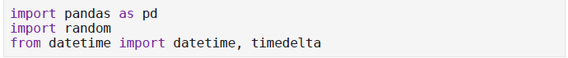

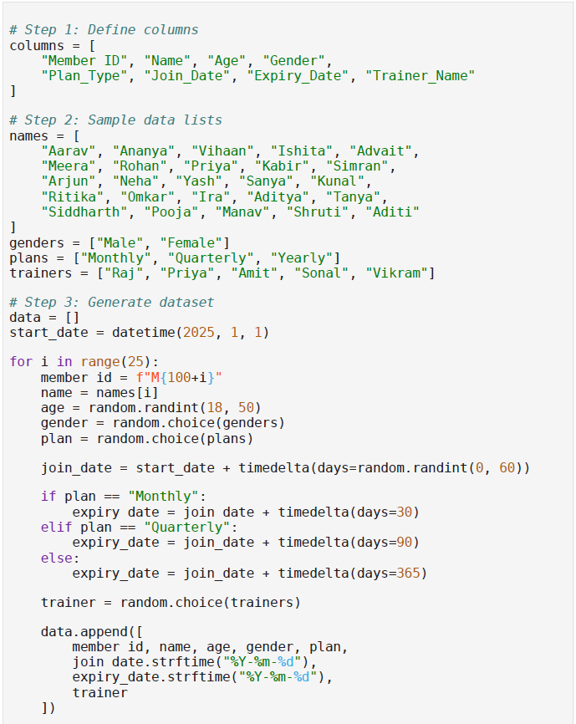

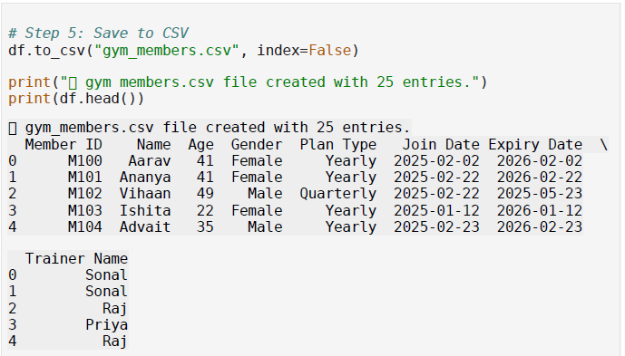

Result:

Thus a dataset is created in CSV format and saved using Pandas Library

